SATISH CHANDRA MEMORIAL SCHOOL
Monthly Test -1
Class-XII
Geography
Time: 1Hr 20 Min Total Marks: 30
- Which are the common features for all processing in secondary activities? Explain them. (3)
- How do government adopt welfare attitude in their activities? (3)
- How do Bhutanese calculate development in their country instead of HDI? (3)
- Why do the people in cold region survive on hunting? (3)
- Why is commercial livestock rearing a specialised activity ? (3)
- In what ways plantation agriculture is seemed to us an industry? (3)
- How far market is an important factor for Diary Farming? (3)
- In which model of agriculture grape is produced in Kazakhstan? Why cattle rearing and poultry farming is called factory farming? 1+2=3
- What ways rearing of animals in ranches beneficial? Why the number of pastoral nomads decreasing? 1+2=3
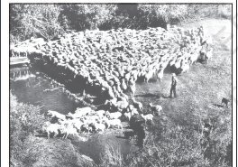
- Study the given picture and answer the following questions: 1+1+1=3

  - Name the activity?
  - Name the region where is it practiced?
  - Why producers in primary activity are called red collar?

